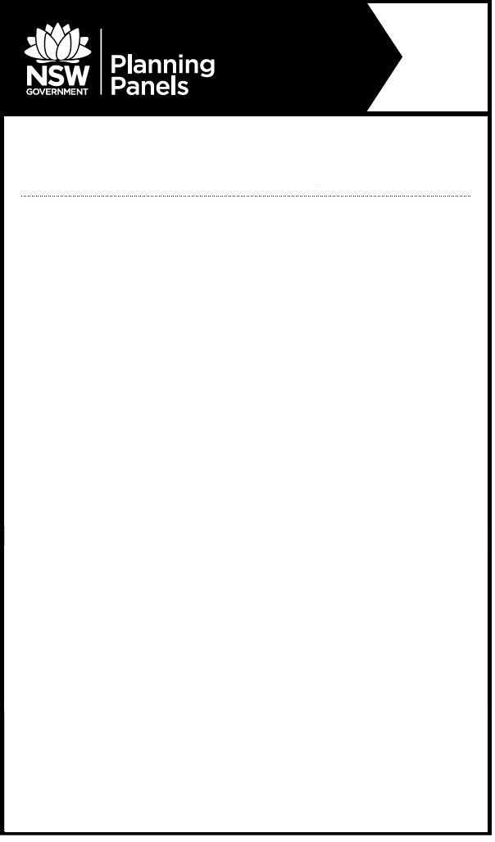

**Notice of Public Meeting Cancellation**

**Sydney South** **Planning Panel**

**The following meeting has been cancelled and the matter has been removed from the agenda.**

The panel was to meet to determine the following:

PPSSSH-78 – Sutherland – DA-21/0562 – 3 – 23 Kingsway, Cronulla 2230

Demolition of existing structures and construction of a nine-storey mixed use development and three levels of basement parking.

The meeting was to be held:

**When:** Tuesday, 14 June 2022 at 1:O0 PM

**Where:** The meeting will be held by public teleconference

You will be notified once a new meeting is scheduled.

**For more information:** (02) 8217 2060

www.planningportal.nsw.gov.au/planningpanels